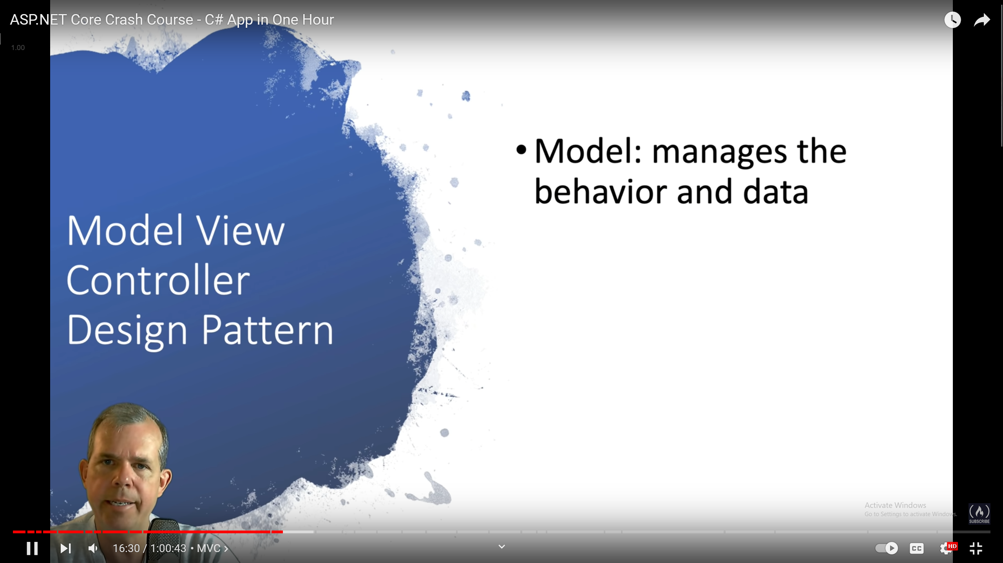

So the model is a class so we gonna make a model for our joke

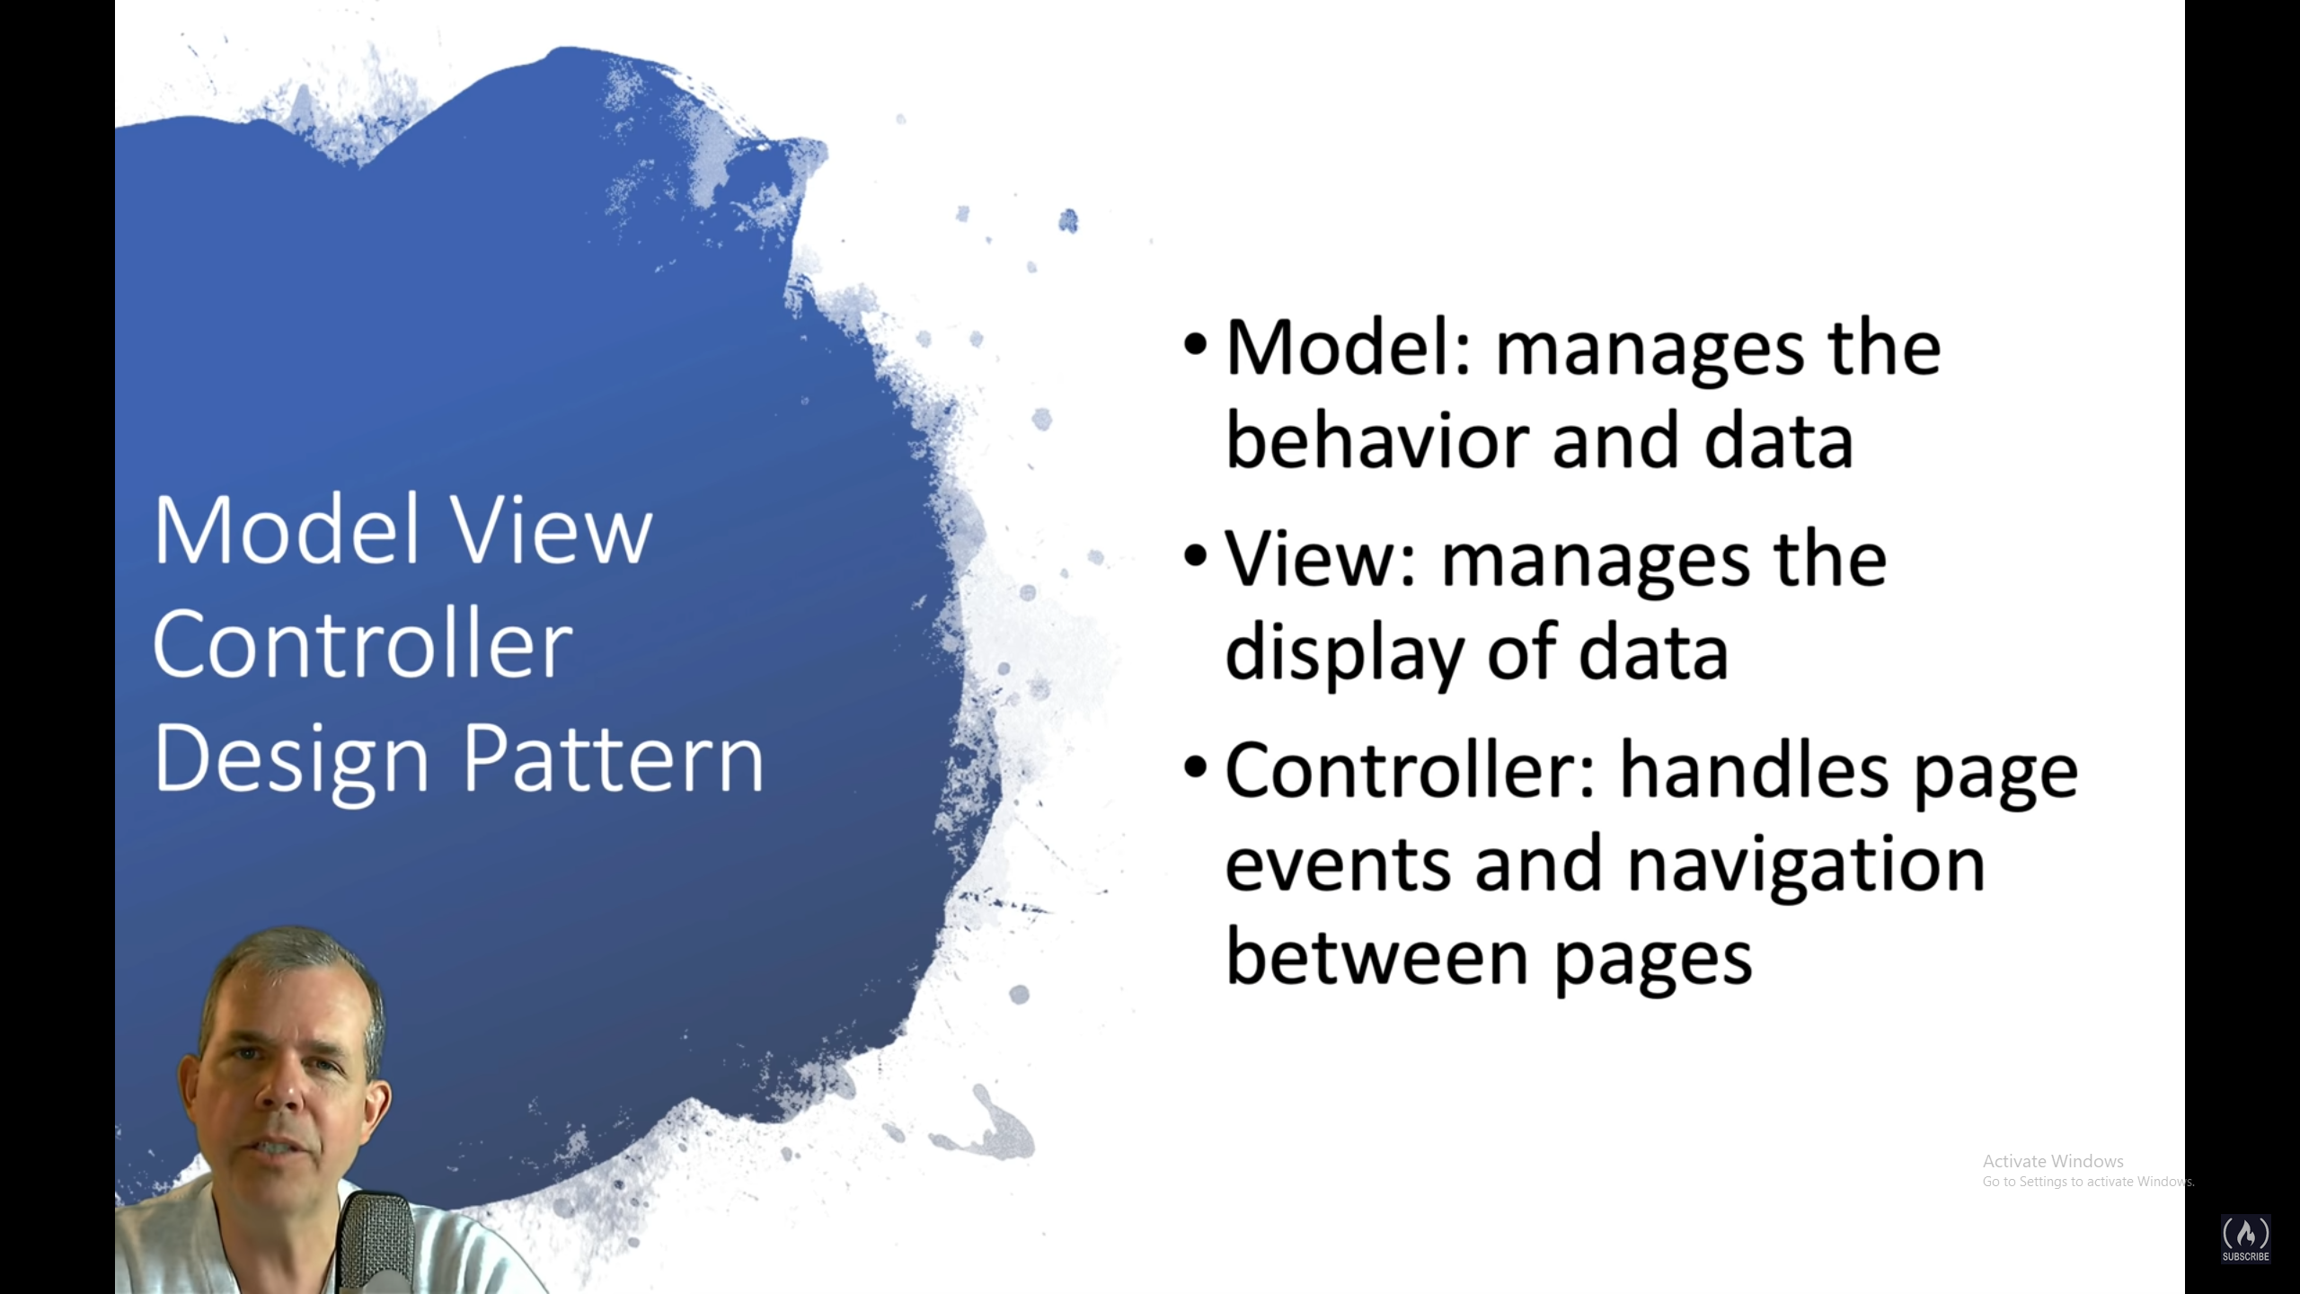

The controller handles the logic of the code like it’s the code’s brains

We gonna create some pages dynamiccly:

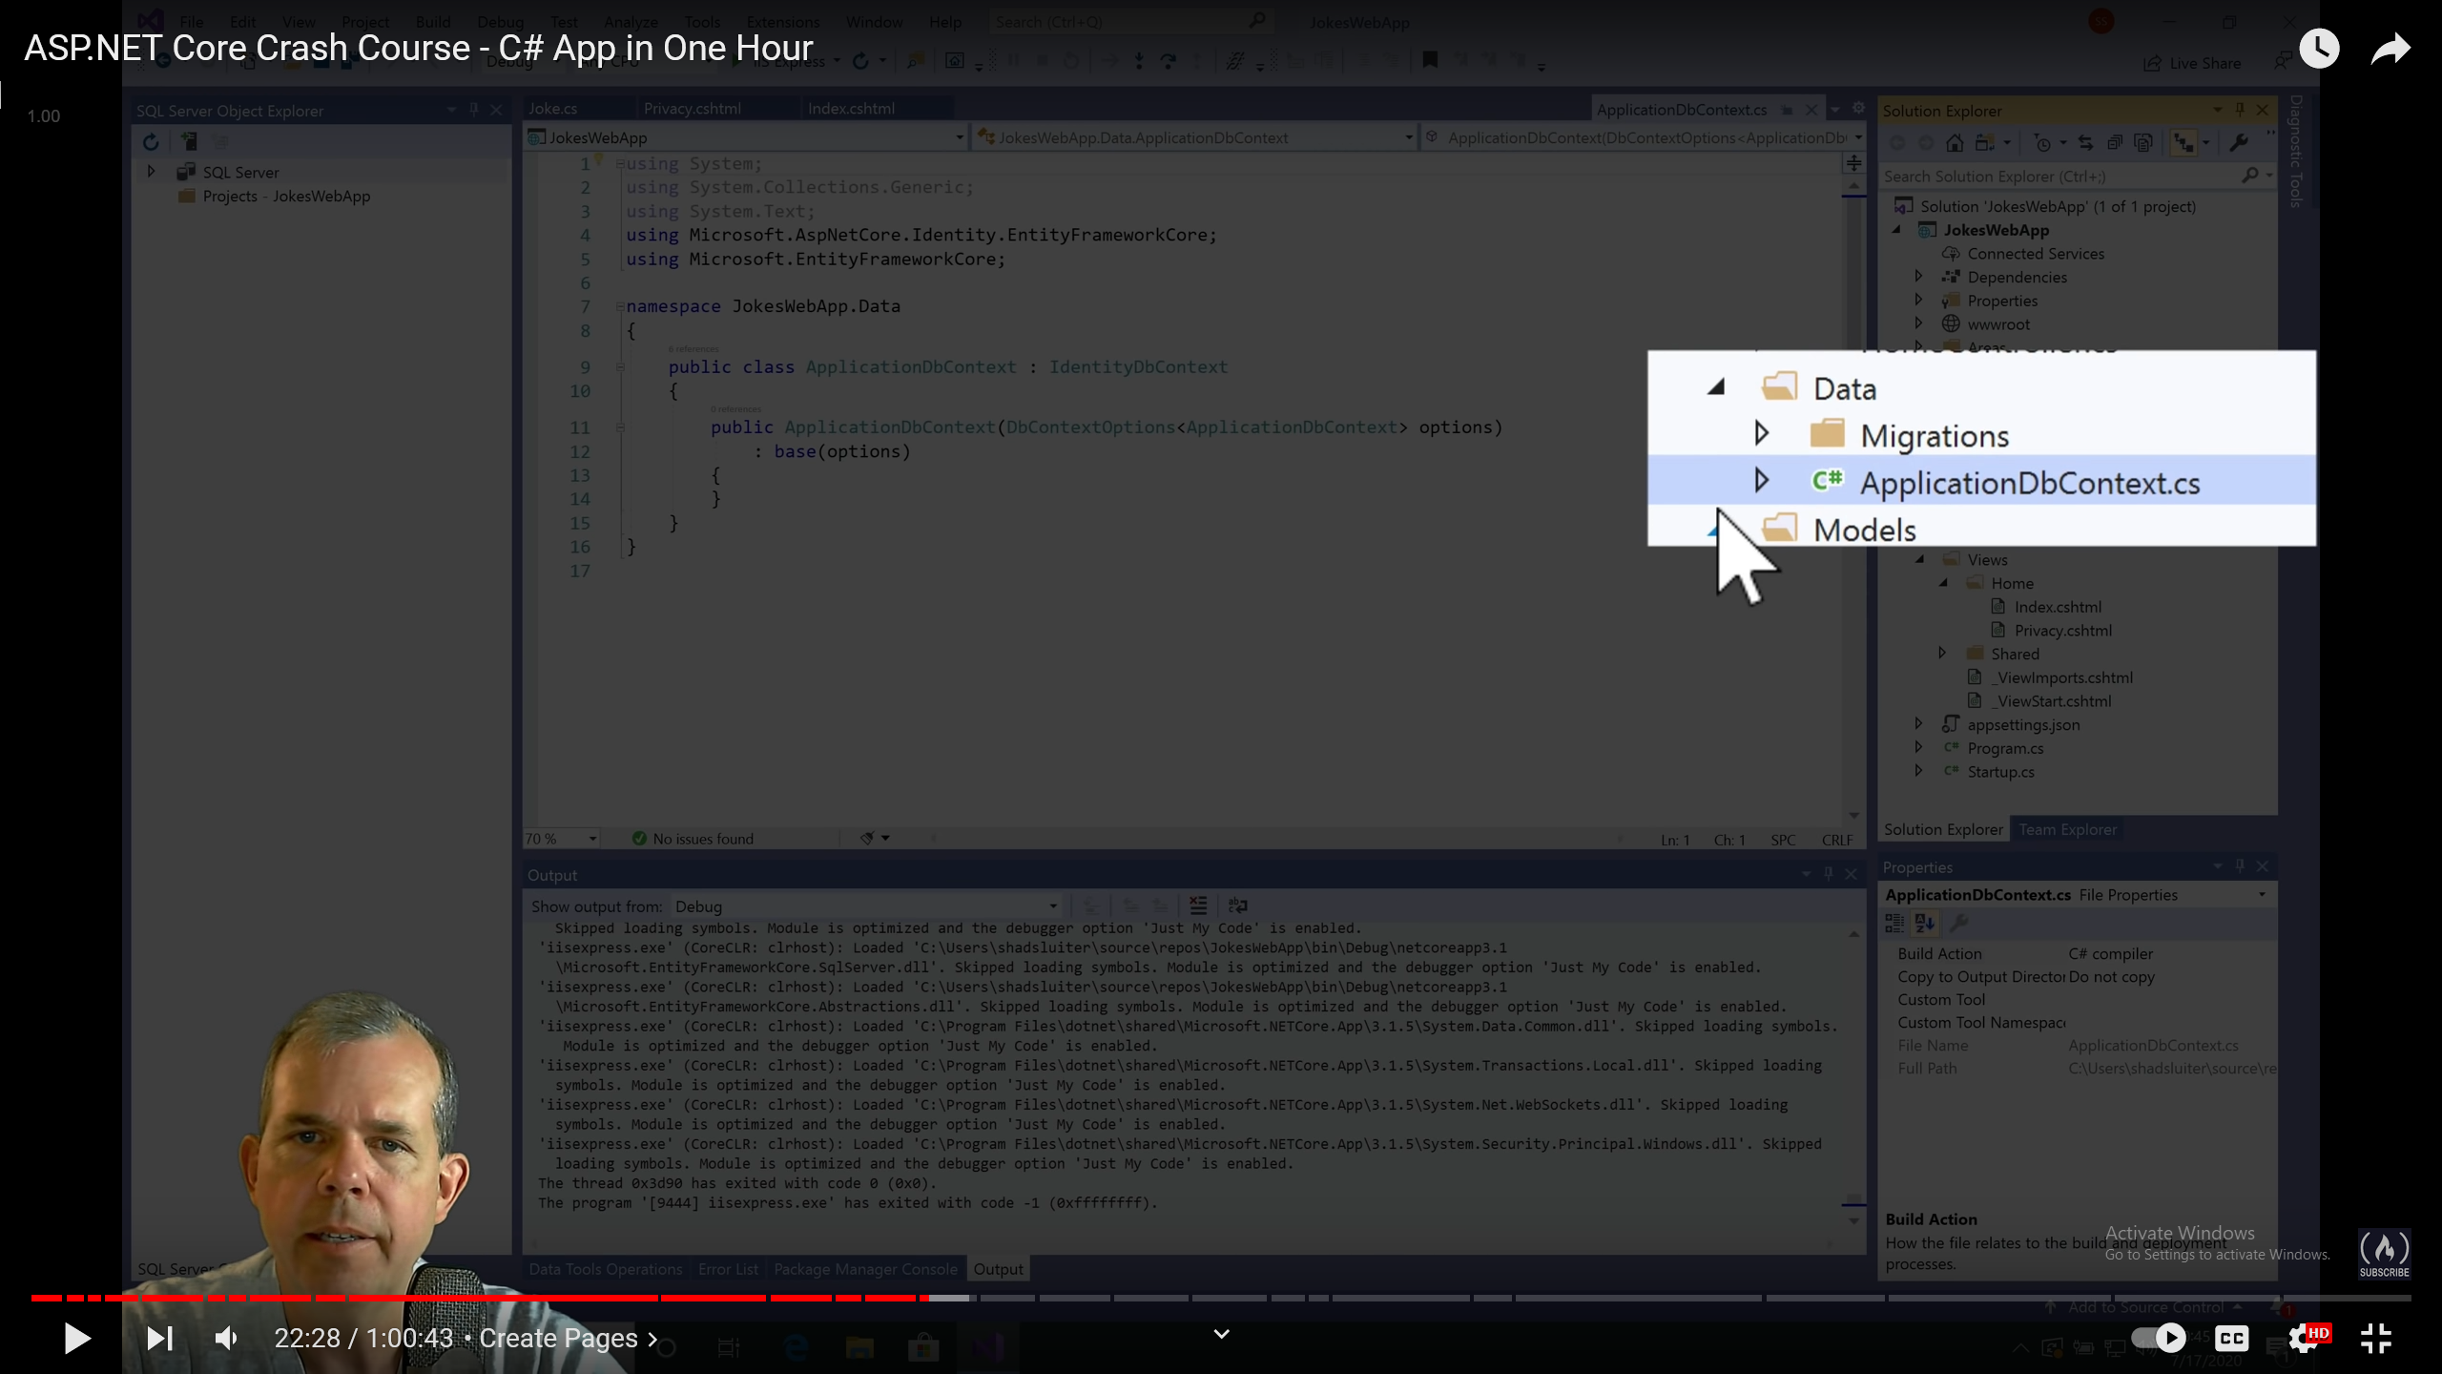

This app is here and I don’t know what it does

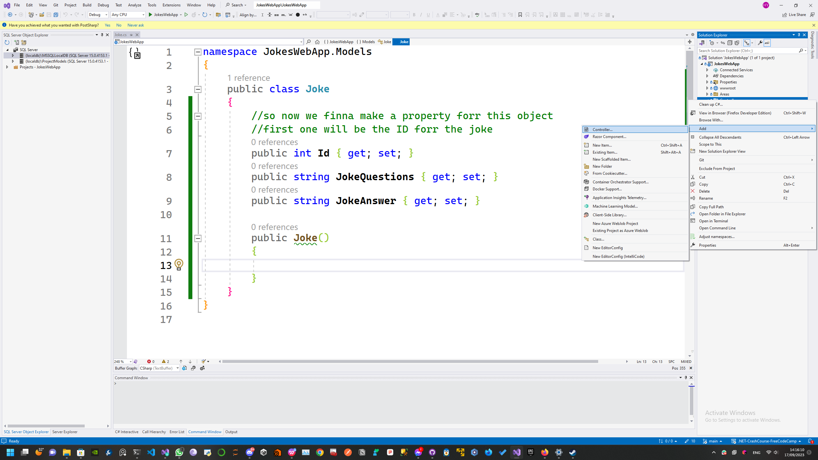

So from the controllers we can click on add > controllers to create a controller

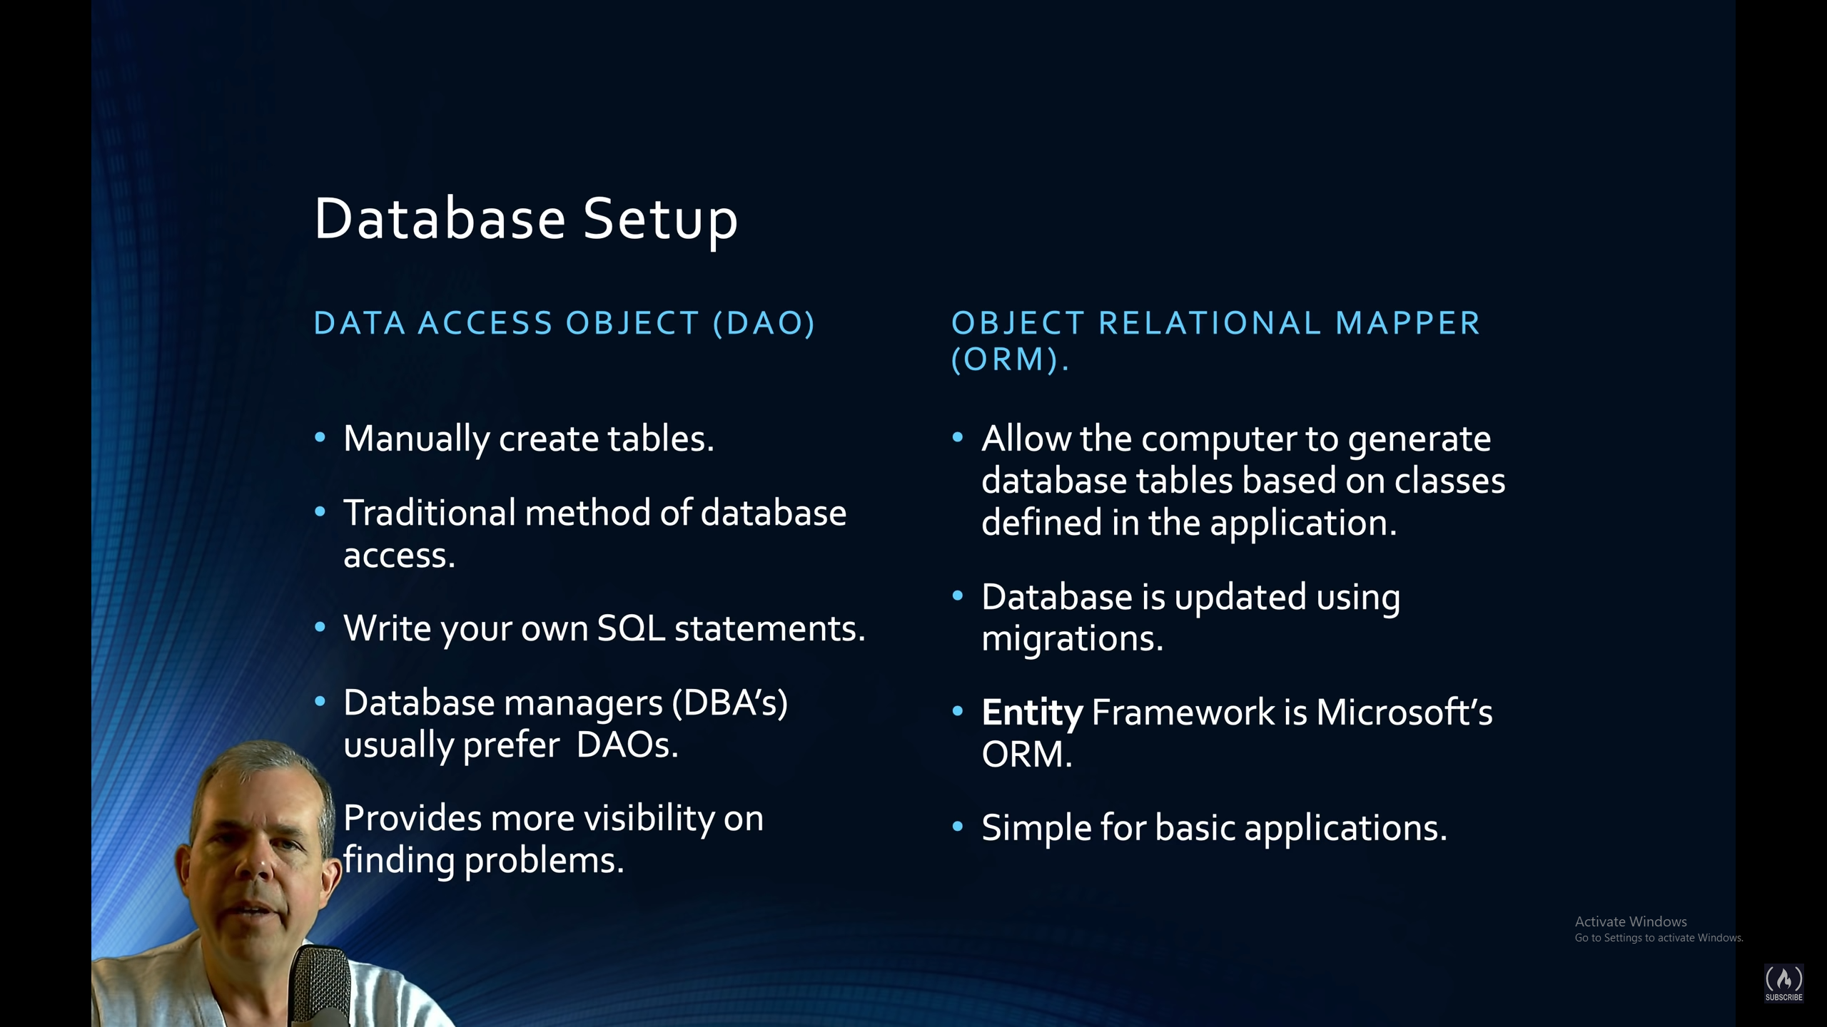

There are two ways to create a database, 1. DAO where in it you write all the queries by yourself

1. ORM where in it you use a tool to create the database for you